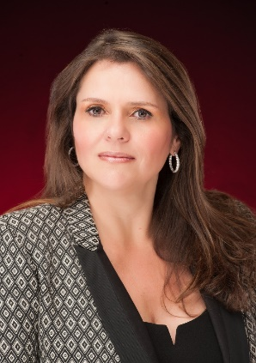 | ANA MARIA PIUMBINI WALTERS  Board Director | CEO, American Photonics | Global Growth and Transformation Executive  Sarasota, Florida | (941) 286-0960 | ana@americanphotonics.com | anafloridausa@gmail.com  linkedin.com/in/ana-piumbini-20b0b84a/

Ana Maria Piumbini Walters is a board director and global C-level executive with more than 30 years of leadership experience across optics manufacturing, technology, retail, real estate and client services. She currently serves as a director for Freedom to Belong, US Legal Now, American Photonics and Forever Realty Investments LLC, while leading American Photonics as CEO and shareholder.
EXECUTIVE BIOGRAPHY
Based in Sarasota, Florida, Ana brings a rare combination of global operating experience, entrepreneurial leadership and board-level perspective. Her career has included CEO, president-level and commercial leadership roles across the United States and Brazil, with responsibility for P&L, strategy, sales, marketing, operations, international trade, investments and contract negotiation.
Since 2014, Ana has led American Photonics, an infrared optics manufacturing company with an international customer base. She restructured the company's distribution approach from a concentrated national distributor model into diversified worldwide channels, rebranded the business and modernized its marketing and visual communications. Under her leadership, the company expanded global market share from 3% to 15% within four years.
Ana also serves as CEO and director of Forever Realty Investments LLC, where she manages real estate and financial investment strategy, portfolio growth and risk oversight. In addition, she leads Gaia DBA Total Help Sarasota, overseeing immigration support operations, multilingual client service and cross-border support for clients connected to the United States and Brazil. Her director roles with Freedom to Belong and US Legal Now add to a governance portfolio that combines business growth, inclusion, community service and practical operational oversight.
Before American Photonics, Ana served as CEO and shareholder of Granite Forever, USA, an importer and manufacturer of granite countertops with installation operations throughout Southwest Florida and customers including Home Depot, Lowe's and more than 150 cabinet and remodeling companies.
Ana's earlier career in Brazil included senior leadership roles with Microsoft Brazil, GPA - Grupo Pao de Acucar, IBM Brazil, Fast Shop, Carrefour Hypermarket Brazil and Visual Presence Brazil. She became the first female National Director of Retail Sales for IBM Brazil and helped pioneer the sale of personal computers through supermarket and retail channels in Brazil, creating new routes to market for major technology brands.
Her education includes executive education in Artificial Intelligence from Harvard University, Harvard executive education on competing in the age of AI, board director development at the Kellogg School of Management at Northwestern University, post-MBA executive education at Kellogg, an MBA in Business Management, postgraduate study in Advertising and Marketing, and bachelor's degrees in Business Management and Systems Analysis.
Ana is fluent in English and Portuguese and conversational in Spanish and Italian. She became a naturalized citizen of the United States in 2018 and is the author of Reviewing the Comedy on the Corporative World, published by Novatec in Brazil.
CURRENT BOARD AND EXECUTIVE ROLES
Freedom to Belong | Board Director
US Legal Now | Board Director
American Photonics | Board Director, CEO and Shareholder
Forever Realty Investments LLC | Board Director and CEO

